A. Levels of organisation and interactions
- What is the definition of an ecosystem?
- What is the definition of an abiotic factor?
- List three abiotic factors which can affect an aquatic organism.
- List three abiotic factors which can affect a plant.
- What is the definition of a biotic factor?
- List three biotic factors which can affect a community.
- Complete the table:
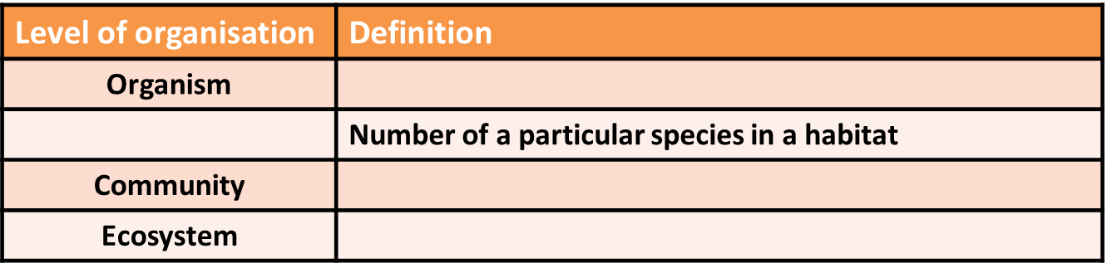
- List two ways a daisy plant may depend on another species for its survival.
- Define the term interdependence.
- What is the definition of a parasitic relationship?
- Name two parasitic organisms and their hosts.
- What type of relationship exists between a bee and a flowering plant?
- What is a quadrat used for?
- If a quadrat has sides of 0.5m, what is the area of the quadrat?
- What is the equation for calculating the mean number of organisms of a species in a specific area?
- What equipment would be needed to measure how species distribution changes from an area of high light intensity to a shaded area?

B. Trophic levels, biomass and energy transfers
- What is biomass?
- What does a food chain show?
- What do all food chains begin with?
- Name two different types of organism which would be found at the start of a food chain.
- What is meant by the terms mode and median?
- Define the term trophic level.
- What does a pyramid of biomass represent?
- How much energy as a percentage is transferred by producers from incident light for photosynthesis?
- Approximately how much biomass, as a percentage, is transferred from a trophic level to the one above it?
- List two ways in which biomass can be lost at each stage of a food chain.
- What is the equation which should be used to calculate the efficiency of biomass transfer between trophic levels as a percentage?

C. Biodiversity and the effects of humans
- Define the term biodiversity.
- List one positive impact that humans can have on biodiversity within an ecosystem.
- What causes eutrophication?
- List three ways that fish farming can reduce biodiversity.
- What is a non-indigenous species?
- List 3 benefits to humans of maintaining local biodiversity.
- List 1 benefit to the wildlife of maintaining local biodiversity.
- What is a biofuel?
- Why do humans undertake large scale deforestation in tropical areas?
- Consider the negative aspects of how humans interact with ecosystems. What could be done positively to counteract this effect?
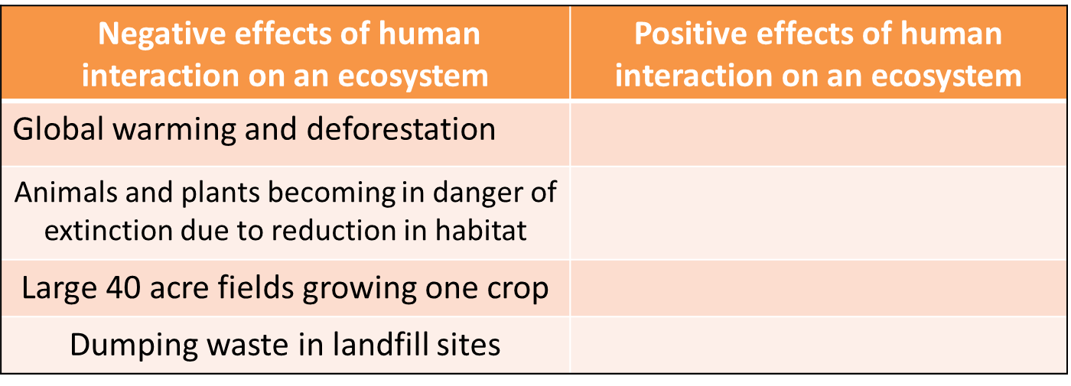
D. Food security BIOLOGY ONLY
- What is meant by the term food security?
- What does sustainability mean in relation to food security?
- List four biological factors which threaten food security.
- Give two ways in which energy transfer to the environment can be restricted in food animals.
- Some farmers feed their animals high protein food. Why?
- List two things which can be done to conserve fish stocks in the ocean at a sustainable level.
- What are agricultural inputs and how can these affect sustainability of food production?
- Name two gases which are increasing in the atmosphere and contribute to global warming.
- List two biological consequences of global warming.
- Name four processes which humans carry out that reduces the land available to other animals, plants and microorganisms.
E. Material cycles, pollution and decomposition
- Why is it essential that materials are recycled in the living world?
- What is precipitation in the water cycle?
- List three main processes in the carbon cycle.
- Name the four types of bacteria involved in the recycling of nitrogen.
- What do plants use the nitrates they take in from the soil for?
- Name three methods a farmer may use to increase the amount of nitrate ions in the soil.
- Give an advantage and a disadvantage to a farmer of using animal waste as a fertiliser.
- Match the correct bacteria to their function in the Nitrogen cycle.
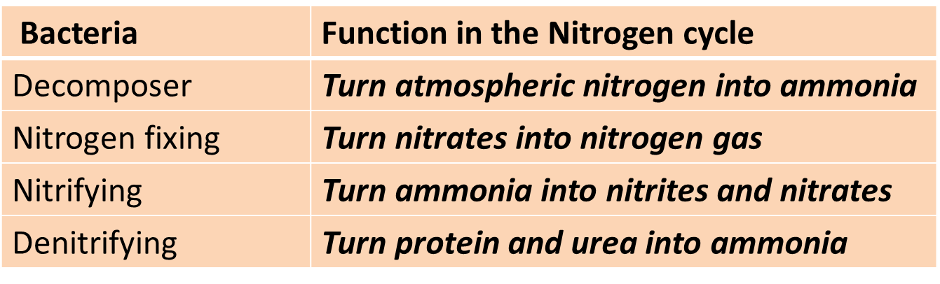
- What is potable water?
- What needs to occur to enable seawater to be potable?
- Name two methods of removing the excess mineral ions from seawater.
Biology only
- Name three factors which must be present for the rapid decay of waste biological material to occur.
- What do gardeners call the end product after waste biological material has decayed?
- What is this end product then used for?
- What might cause anaerobic decay to occur?
Higher tier Biology only
- What is an indicator species?
- Name an indicator species which is only found in clean water.
- Name an indicator species which may be found in polluted water.
- Name two indicator species which can be used to assess the level of pollution in air.
- Give an advantage of using dissolved oxygen meters to measure water pollution instead of an indicator species.
- Give a disadvantage of using dissolved oxygen meters to measure water pollution instead of an indicator species.

